**English Academic Writing and Communication Assignment 1**

**Name (Chinese/English):Ge Haizhou**

**Student ID:2023312829**

1. **Replace the following words and phrases with the formal ones in the box. (5%)**

give:_ appoint_____

1. detrimental E. realm
2. implicit
3. deplete
4. appoint

indirect:__ implicit_______

area:___ realm_____

harmful:___ detrimental______

use up:___ deplete____

1. **Rewrite the following sentences. (20%)**

Other work shows that some pre-service teachers also attribute the cause of climate change to the depletion of the ozone layer. (Paraphrasing)

Other studies indicate that some prospective educators also ascribe climate change to the depletion of the ozone layer.

Still, we’ve got a long way to go before nanotechnology dominates the technology market. (Paraphrasing)

Nonetheless, significant progress needs to be made before nanotechnology becomes the predominant force in the technology market.

The key factor of divorce is gender hierarchy and gender inequality. (Hedging)

The primary factor contributing to divorce appears to be linked to gender hierarchy and gender inequality.

Everybody agrees that the main cause of the financial crash was sub-prime mortgage lending. (Hedging)

There is a general consensus that one of the main factors contributing to the financial crash was likely sub-prime mortgage lending.

1. **There are eight errors in this paragraph. They are in word forms (1), articles (2), modals (1), verb tense (2), and subject-verb agreement (2). Mark these errors and write corrections. (10%)**

Washington and Lincoln ~~was~~ were ~~similarly~~ similar in several ways. Both men ~~are~~ were the U.S. presidents. Both men served the United States during extremely difficult times. For Washington, the question ~~is~~ was whether the United States would be able to maintain its independence from Britain. The United States was certainly a very fragile nation at that time. For Lincoln, the question ~~were~~ was really not so different. Would the United States ~~to~~ be able to survive during what was one of the darkest periods of American history?

1. **Summarize the main idea of the following paragraph using one sentence only. (15%)**

Several consumer surveys have been conducted in different regions of China regarding awareness of, acceptance of and willingness to buy GM foods, with highly discrepant results. At one extreme is a study by Greenpeace which claimed that GM foods were not generally accepted by Chinese consumers(cited in Huang et al., 2006); at the other are studies indicating positive attitudes towards GM foods, although consumers have little knowledge of such foods(Li et al., 2002; Zhong et al., 2002). A recent very extensive study of 1,005 households randomly selected in 11 cities in northern and eastern China reported that the percentages of the consumers’ approval of and willingness to buy GM foods in China were high. In general, the acceptance rates were much higher than all other countries, that have been reported in the literature"(Huang et al., 2006). A reservation pertaining to these consumer surveys is the risk that the GM issue was examined as a single cue, which may have given this characteristic undue prominence in respondents minds.

Consumer surveys in various regions of China showed conflicting results on the acceptance of genetically modified (GM) foods, raising concerns about the potential influence of examining the GM issue as a single cue.

1. **Read the following abstracts and analyze the functions of the sentences in an abstract. You need to label the functions within a [ ] in bold. Read the model carefully before the exercise. You may have other function labels when applicable. (10%)**

**Model:**

**Academic Dishonesty Among College Students**

**Abstract**

The present study investigated the effects of academic motivation, academic integrity, attitude toward cheating, and self-efficacy on cheating behaviors of college students. **[the objective]** Participants completed a puzzle-solving task in which some puzzles were not solvable unless a participant cheated. One group was offered a 20 dollar reward for the highest score, the second group’s scores were made public, and the third group served as the control. **[methods employed]** There was not a significant difference in the cheating behaviors of the three groups. A significant negative correlation was found between participants’ self-reports of cheating behaviors and how dishonest they rated those behaviors. Participants who cheated on the puzzle task had significantly higher self-efficacy scores than those who did not cheat. Implications for these findings are discussed. **[major findings]**

**Your task:**

**Influence of Genetically Modified Soya on the Birth Weight and** **Survival of Rat Pubs**

**Abstract**

Investigation of the influence of GM soya on the birthrate and survival of the offspring of Wistar rats were performed in this paper. [ **the objective** ] A group of female rats were fed GM soya flour before mating and pregnancy. The control group of females were fed traditional soya and the third group of females, the positive control group, received feed without any soya. The weight and the mortality rate of the newborn pups were analyzed. [ **methods employed** ] The study showed that there was a very high rate of pup mortality (55.6%) in the GM soya group in comparison with the control group and the positive control group (9% and 6.8% respectively). Moreover, death in the first group continued during lactation, and the weights of the survivors are lower those from the other two groups. [ **major findings** ] It was revealed in these experiments, that GM soya could have a negative influence on the offsprings of Wistar rats. [ **conclusion** ]

1. **Complete the following paragraph by giving in-text citations and references with APA/IEEE style according to the source information given on the next page. (15%)**

One of the main problems tourists cause in Antarctica is the disruption of scientific research being conducted there. While scientific study in Antarctica was once the main purpose for human presence there, science seems to have given way to tourism. In fact, from 1990, the number of tourists began to increase to a point where their numbers now exceed the number of scientists ( [1] ). Initially, this was welcomed by research staff whose projects saw a potential finding boost through an increase in visitors, and scientists who stay in Antarctica all year round welcomed the idea of more human contact ( [2] ). However, it quickly became apparent that the large number of tourists was beginning to have negative impacts on the scientists. According to American University, which funds research in the Antarctica, independent tour companies are often unaware of research schedules and bring hundreds of tourists to scientific sites requesting explanations and tours ( [3] ). In addition, scientists staff sometimes have to stop their work to aid tourists who have either ignored the risks or underestimated the extreme conditions of Antarctica.

**References**

[1] A. Shaik, “*Antarctic wanderlust*,” EJ Magazine, Spring. 2010. Available:

<http://news.jrn.msu.edu/ejmagazine/2010/05/04/>

[2] S. Larson, “More tourists head to Antarctica, affecting the region's ecosystem and science,” Peninsula Press, May 11, 2010. Available: http://peninsulapress.com/2012/

/05/11/

[3] J. Grall, “Antarctic tourism impacts,” TED Case Studies, 2(1), 1992. Available: http:/

/www.american.edu/TED/antarct.htm

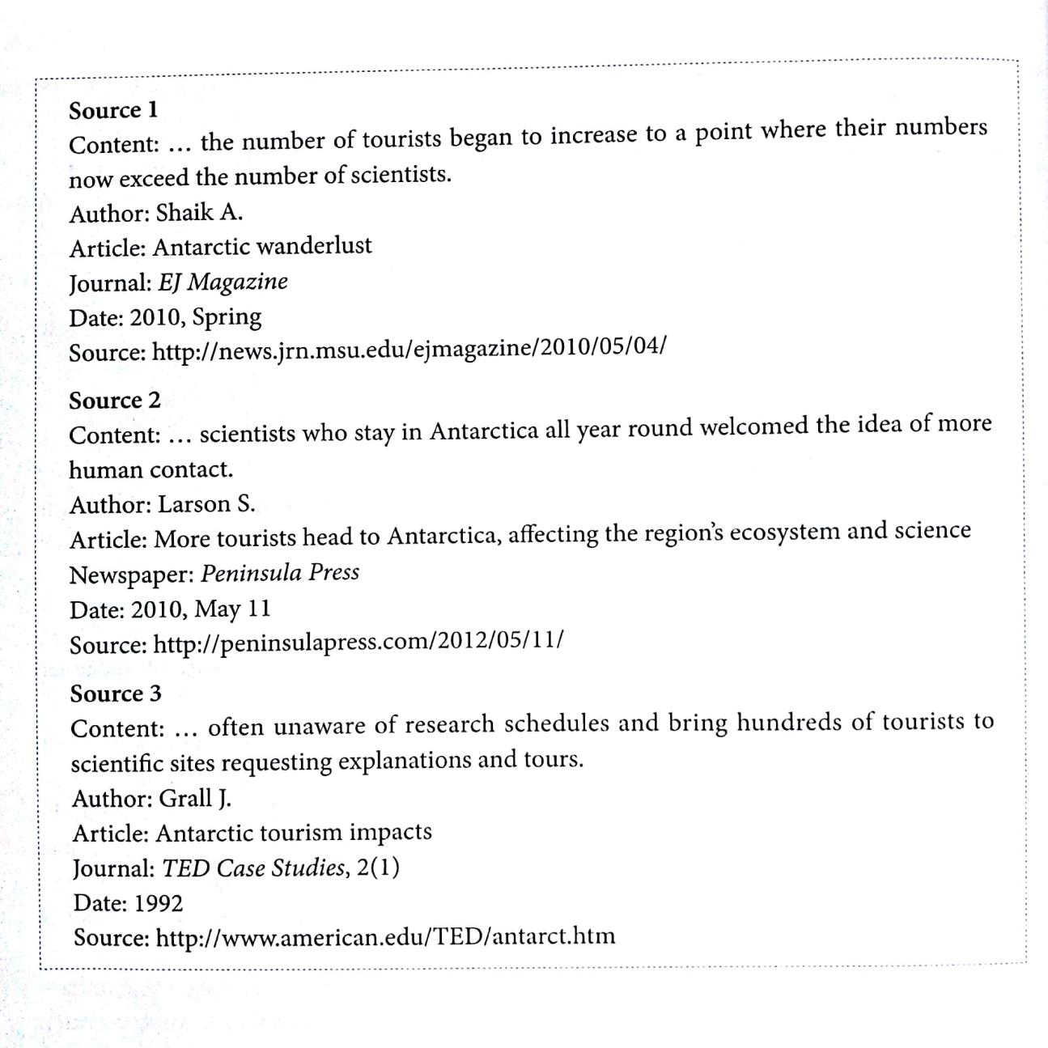

1. **For this part, you are required to write a report describing the information given below. This chart gives information about global sales of games software, CDs and DVD or video. You should write at least 130 words but no more than 180 words. (25%)**

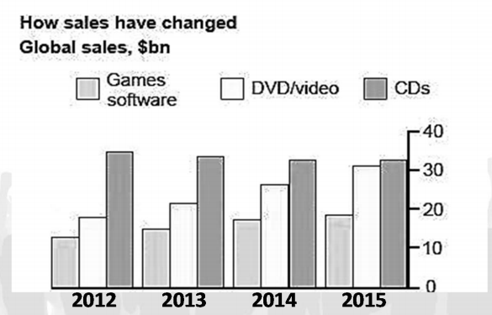

**Your report:**

The column chart compares the global sales of games software, CDs and DVD/video between the years 2012 and 2015.

In general, there was a notable increase in sales of game software and DVD/video over the four-year period, while the sales of CDs experienced a slight decline.

In 2012, the global sales of CDs amounted approximately to $35 billion, surpassing DVD/video and games software sales, which were around $18 billion and $14 billion, respectively. However, by 2015, the sales of DVD/video and games software rose to about $30 billion and $19 billion, while the sales of CDs dropped to $32 billion. Despite the decline, the sales of CDs remained the highest throughout the period, followed by DVD/video, with games software exhibiting the lowest figures. What’s more, the global sales of these three commodities exhibited a steady annual fluctuation, with DVDs seeing an increase of around $4 billion per year, games software experiencing a growth of approximately $1.67 annually, and CDs decreasing by about $1 per year.